KWAZULU-NATAL DEPARTMENT OF EDUCATION



LEARNER SUPPORT DOCUMENT PHYSICAL SCIENCES GRADE 10

Contents Page

Waves, Sound & Light
Pendulum Investigation 2
Concept map on Waves Sound & Light 6
Transverse pulses on a string or spring 7
Transverse Waves 9
Longitudinal Waves 12
Sound waves 13
Electromagnetic radiation 17
Waves, Sound & light Exam Questions 26
Definitions and Terminology 39
Matter & Materials 41
Matter and classification of matter 41
States of matter and the kinetic molecular theory 48
Atomic Structure 51
Periodic Table 57
Chemical Bonding 59
Matter & Materials Exam Questions 64

Waves, Sound & Light

ACTIVITY: Pendulum Investigation
Rationale
The study of the pendulum is not an explicit requirement in CAPS. However, this investigation has been designed to develop conceptual thinking about the relationship between terms like amplitude, period and frequency.
This investigation also provides the opportunity to revise the Scientific Method
and make sure that Grade 10 learners have the basic skills required to complete practical assessment tasks.
Instructions
- Work in groups of four.
- This is a guided practical activity. You are required to stay on task and respond in the time allocated.
Investigation: A simple pendulum Part 1: Demonstration of a pendulum
Watch the pendulum swinging
a.) Describe the motion of a pendulum
b.) What factors may affect the time taken for one swing?
Solutions:
a.) Learners need to explain in their own words. Guide them to think about when the bob of the pendulum is at rest, maximum speed, slowing down and speeding up.
From a position of maximum displacement from the rest position the bob has zero velocity. The bob accelerates as it moves towards the rest position (not constant acceleration). At the rest position, the bob is moving at max velocity. The velocity decreases as the bob moves towards the position of maximum displacement. The bob experiences a
negative acceleration that is not constant.

b.) Mass of bob, length of string, angle of release (distance from rest position)
Part 2: Thinking activity
As a group, predict which of the following pendulum will take longer to complete one complete swing or cycle:
- A heavy, long pendulum, starting in position where the angle from the vertical is more than 45°
- A light, long pendulum, starting in position where the angle from the vertical is equal to 45°
- A heavy, short pendulum, starting in position where the angle from the vertical is less than 45°
Solution: All answers accepted. The most correct answer A or B
Part 3: Think about Thinking
a.) Explain the process you went through to come to your answer
b.) If you had to design a practical activity to test your thinking but were only allowed two swings, which combinations would you select:
Test 1

Test 2

Solutions: Depends on learners answers. No answer is incorrect. Most correct option: Long pendulum compared to a short pendulum

Part 4: Design & Testing
Use the apparatus you have been given to confirm your thinking in Part 3

 | Combination | Time 1 | Time 2
Test 1
Test 2

a.) What conclusions if any can you make from the results of your practical investigation?
b.) Is it good enough to time one swing or should you find an average? b.) What other combination would you like to test to be sure?
c.) Complete a third test and record your results:

 | Combination | Time 1 | Time 2
Test 3

d.) What conclusions if any can you make from the results now? Solutions: Depends on learners answers. No answer is incorrect. It is important that learners relate variables given. Conclusions should only be drawn when there is a change in one independent variable (e.g length of string) which relates to a significant change in the dependent variable (time taken for a complete cycle).
Note: Some readings will be very similar but this depends on experimental error. It is recommended that the time taken for one cycle is measured more than once to ensure precision and accuracy. It is suggested that learners take the time for 10 swings and then divide the time by 10 to get an average time for one swing. This should be repeated so that results are precise.
The most significant differences are for a long and a short pendulum.

Part 5: Cognitive Conflict
- Is the difference in time between the tests significant?
- What would you change if you wanted you pendulum to swing at twice the speed?
- John believes that a heavy pendulum will have a smaller period. Do you agree or disagree with him?

Solution:
- Difference in time for different masses and different angles is insignificant. Difference in time for different lengths of pendulum is significant.
- Must shorten the length of the pendulum.
- Mass has no effect on period of pendulum.

Reflection
From this investigation you should have revised the following terms:
  - Independent variable
  - Dependent variable
  - Control variable
  - Period – time taken for a complete cycle
  - Amplitude – maximum displacement from the rest position
  - Frequency – the number of cycles in a given time
  - Precision – how closely data is grouped together
  - Accuracy – how close experimental data is to the recorded data.

Follow up activity
Use the pendulum to collect data:

Number of swings | 1 | 2 | 5 | 10
Period

Plot a graph to show the relationship between the period and the number of swings (cycles).
Use the graph to find the number of cycles in 1 minute.

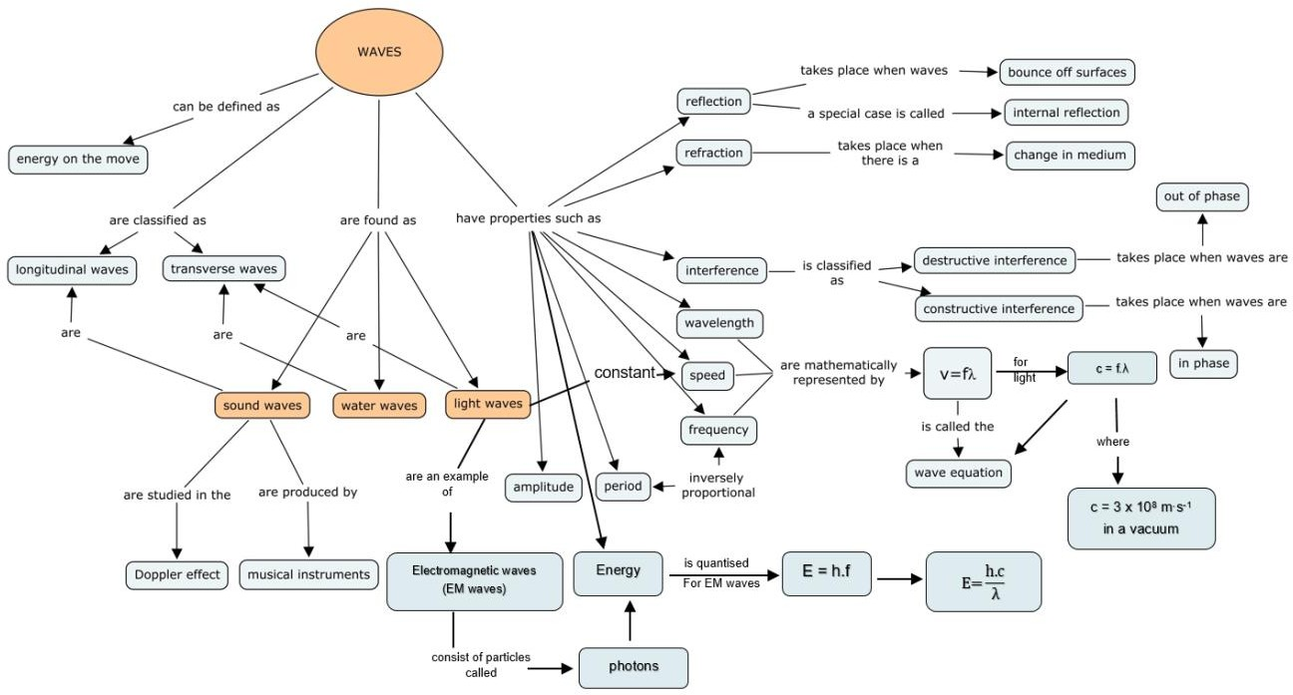
Concept Map of Waves, Light & Sound

Page 6

TRANSVERSE PULSES ON A STRING OR SPRING PULSE AND AMPLITUDE
- A pulse is a single disturbance (vibration) in a medium.
- A transverse pulse is a pulse in which particles of the medium moves at right angles to the direction of motion of the pulse.
- A transvers pulse has amplitude and pulse length.
- Amplitude is a maximum disturbance of a particle from its rest (equilibrium) position.
Practical activity: Generating a pulse
- Flick the rope or slinky spring at one end only once, while the other end is fixed.
- Learners observe the motion the pulse

Amplitude
Position of rest

SUPERPOSITION OF PULSES
- The principle of superposition is the addition of the amplitudes of two pulses that occupy the same space at the same time.
- Constructive interference takes place when two pulses meet each other
to create a larger pulse (see illustration below) i.e. when a crest meets another crest or a trough meets another trough.

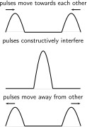

- Destructive interference takes place when two pulses meet and results in a pulse of reduced amplitude i.e. when a trough meets a crest.
- The amplitude of the resulting pulse is the sum of the amplitudes of the two initial pulses, but one of the amplitudes will be a negative number.

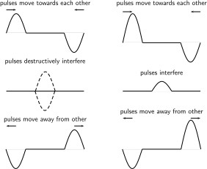

TRANSVERSE WAVES
- A transverse wave is the wave in which the particles of the medium vibrate at right angles to the direction of motion of the wave.
Practical activity: generating a transverse wave
- Flip one end of the rope or slinky spring up and down continuously to create a train of pulses.
DEFINITIONS
Diagram of a transverse wave

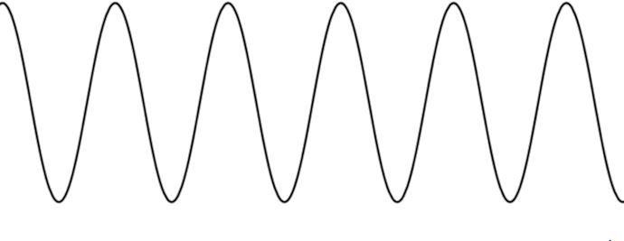
D
A
E
H
I
G
B
C
F

A: Amplitude
- Amplitude is the maximum displacement of a particle from its equilibrium position (rest position).

B. Wavelength
- Wavelength is the distance between two successive points in phase.
C: Trough
- Trough is the lowest point on a wave.

D: Crest
- Crest is the highest point or peak on a wave.
- EH: Equilibrium position/position of rest is the centre line that shows the position of undisturbed string or spring.

Points in phase: C and F are in phase G and I are in phase
- Points in phase are two points in phase separated by a whole number multiple of complete wavelengths.

F and G: Points out of phase
- Points out of phase are points that are not separated by a whole number multiple of complete wavelengths.

- Period (T) is the time taken for one complete wave pulse.
o T = 1
𝑓
- Period is measured in seconds(s).
- Frequency (f) is the number of wave pulses per second.

o f = 1
𝑇
- Frequency is measured in hertz (Hz).
- Wave speed (v) is the distance travelled by a point on a wave per unit time
- v = f.λ (wave equation)

Quantity | Symbol | Unit | Symbol
Speed of wave | v | metre per second | m·s-1
Frequency | f | Hertz | Hz
Wavelength | λ | Metre | m

Worked Examples Example 1
When a string is vibrated at a frequency of 10 Hz, a transverse wave of wavelength of 0,5m is produced. Determine the speed of the wave as it travels along the string.

Solution
Formula: v = f.λ
Substitution: = (10)(0,5)
Answer: = 5 m·s-1
Example 2
A wave with a wavelength of 1,5 m moves past a point in 20 seconds. 60 complete waves are completed. Calculate the:
  - frequency of the waves
  - period of the waves
  - speed of the waves
SOLUTIONS

2.1 f = number of waves time
= 60 ÷ 20
= 3 Hz
2.2 T = 1 ÷ f
= 1 ÷ 3
= 0,33 s
2.3 v = f.λ
= (3 )(1,5)
= 4,5 m.s-1

EXAMPLE 3
A wave has a frequency of 400Hz and a wavelength of 0,75 m. Calculate the speed of the wave.

SOLUTION
Given data:
f = 400 Hz λ = 0,75 m

v = f.λ
= (400 )(0,75)
= 300 m.s−1

LONGITUDINAL WAVES
- A longitudinal wave is a wave where the particles of the medium vibrate parallel to the direction of motion of the wave.

Practical Activity
How to generate a longitudinal wave
- Take a slinky spring and hang it from the ceiling. Pull the free end of the spring and release it.

Diagram for longitudinal waves

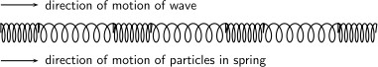

Properties of a longitudinal wave
- A compression is a region of high pressure in a longitudinal wave.
- A rarefaction is a region of low pressure in a longitudinal wave.

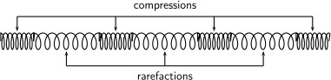

- The wave equation v = fλ is also used to solve problems involving longitudinal waves.

SOUND WAVES
- A sound wave is an example of a longitudinal wave
- Vibrations in a medium in the direction of propagation create sound waves.
- Sound wave cannot be propagated in a vacuum.
- Speed of sound depends on the properties of a medium; it travels faster in a medium with particles closely packed.
- Sound waves travel faster through liquids, like water, than through the air because water is denser than air.
- Sound waves travel faster in solids than in liquid because a solid is denser than a liquid
- e.g.

Medium | Speed (m.s-1)
Air | 340
Water | 1500
Steel | 5900

ECHOES
Sound waves can be reflected by hard surfaces like walls and cliffs. The reflected sound is called an echo.

CALCULATIONS BASED ON ECHOES

Example 1
A man stands between two tall buildings. When he claps his hands, he hears an echo from one building after two seconds and an echo from the other building after three seconds. Calculate the distance that the buildings are apart from each other. Take the speed of sound as 330 m.s-1.

Solution.
For building 1:
Distance = speed × time
= 330 × 1
=330 m.
For building 2:
Distance = speed × time
= 330 × 1,5
= 495 m.
Distance between 2 buildings = 330 + 495
= 825m.

Example 2
The speed of sound in seawater is 1500 m.s-1. A fishing boat sends signals out that are received after 20s. Calculate the depth of the seabed at that position.

Solution.
(time taken for signal to reach the seabed = 20/2 = 10 s) Distance = speed × time
= 1500 × 10
= 15 000 m.

CHARACTERISTICS OF SOUND PITCH
- The frequency of a sound wave is what your ear understands as pitch.
- The pitch represents how high or how low the note sounds.
- A higher frequency sound has a higher pitch, and a lower frequency sound has a lower pitch.(frequency is directly proportional to pitch)

LOUDNESS
- The amplitude of a sound wave determines its loudness or volume. Loudness is the listener’s evaluation of amplitude.
- A larger amplitude means a louder sound, and a smaller amplitude means a softer sound. (loudness is directly proportional to the amplitude)
- Loudness is measured in decibels (dB)

TONE
- The tone is a measure of the quality of the sound wave
- Sound produced by a drum is not of quality because it has different frequencies and it lasts for a short while.(this is noise)

Example.
Two musical notes have the same amplitude, but note A has twice the frequency of note B. In which respects would:
- their sounds differ; and
- their sounds be the same?

Solution
  - Pitch
  - Loudness

ULTRASOUND
- Ultrasound is sound with a frequency that is higher than 20 kHz.
- The most common use of ultrasound is to create images.
- The use of ultrasound to create images is based on the reﬂection and transmission of a wave at a boundary.
- When an ultrasound wave travels inside an object that is made up of diﬀerent materials, part of the wave is reﬂected and part of it is transmitted.
- The reﬂected rays are detected and used to construct an image of the object.

USES OF ULTRASOUND
In medicine:
- To visualise muscle and soft tissue, e.g. during pregnancy
- To generate local heating in biological tissue e.g. to break up kidney stones.

In industry:
Ultrasonic cleaners are used to clean jewellery, lenses and other optical parts, watches, dental instruments, surgical instruments and industrial parts.

ELECTROMAGNETIC RADIATION
- It is produced by charges accelerating through space.
- There are both natural and man-made sources of electromagnetic radiation. The sun, for instance, is an intense natural source of radiation that can have both positive and negative effects on living things. The sun produces both visible (light) and invisible (ultra violet-rays) electromagnetic radiation streams.
- Man-made sources of electromagnetic radiation include X-rays, radio waves, microwaves and gamma rays. Humans to power machines and to increase communication abilities use microwaves and radio waves. Gamma rays are used in chemotherapy. Cell phones, radios, microwave ovens, and radar all create electromagnetic radiation.
- Either using the wave nature or the particle nature of the radiation (visible light) can explain the properties of electromagnetic radiation.
- This property of electromagnetic radiation to have a wave nature and a particle nature is known as wave-particle duality. Light is an example of wave-particle duality.
- Properties of electromagnetic waves
- They originate from accelerating electric charges
- They propagate as electric and magnetic fields that are perpendicular to each other
- They can travel through a vacuum
- They travel with a speed of 3 x 108 m∙s-1
Dual nature of electromagnetic radiation
- Diffraction and interference show that light has a wave particle
- The photo electric effect demonstrates the particle nature

Wave nature will be discussed in grade 11 and particle nature will be discussed in grade 12.
Accelerating Charge
- Accelerating charges emit electromagnetic waves.
- A changing electric field generates a magnetic field and a changing magnetic field generates an electric field. This is the principle behind the propagation of electromagnetic waves.
- Electromagnetic waves do not need a medium to travel through.

Propagation of Electromagnetic Radiation
- Explanation and diagram of the transmission or propagation of electromagnetic radiation:
- Electromagnetic (EM) waves propagate when an electric field oscillating in one plane produces a magnetic field oscillating in a plane at right angles to it.
- The electric field(s) and magnetic field(s) must remain perpendicular to each other.
- EM wave propagation is a mutual induction because the changing electric field is responsible for inducing the magnetic field and vice versa.
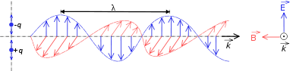
- E is used to show electric field and B is used to show magnetic field ( refer to the diagram of mutual regeneration of electric field and magnetic field below ).

o
- These mutually regenerating fields (Electromagnetic radiation) travel through space at a constant speed of 3 x 108 m.s-1. This constant speed of light is represented by c.

The Electromagnetic Spectrum

EM radiation is classified into types according to the frequency and wavelength of the wave. These types of EM radiation in the table below are in order of decreasing frequency and increasing wavelength (from top to bottom).

Category | Range of Wavelength in  (nm) | Range of Frequency in  (Hz)
Gamma Rays | < 1 | > 3 x 1019
X-Rays | 1 – 10 | 3 x 1017 – 3 x 1019
Ultraviolet Light | 10 – 400 | 7.5 x 1014 – 3 x 1017
Visible Light | 400 – 700 | 4.3 x 1014 – 7.5 x 1014
Infrared rays | 700 - 105 | 3 x 1012 – 4.3 x 1019
Microwaves | 105 - 108 | 3 x 109 – 3 x 1012
Radio Waves | > 108 | < 3 x 109

The Electromagnetic Spectrum in order of increasing wavelength
G X U V I M R
The Electromagnetic Spectrum in order of decreasing wavelength

R M I V U X G

Conversions Table

Unit | Symbol | Unit in metres
Micrometres | 𝜇m | 10-6
Nanometres | nm | 10-9
Pico metres | pm | 10-12

EM radiation is a wave and this equation also applies: v = f λ, however v is replaced by c and the wave equation becomes c = f λ

Calculations using light wave equation c = f λ

Worked examples
- Calculate the frequency of an EM wave with a wavelength of 200nm. Note: nano(n) = 10-9 .

Solution:
Step 1: What do we know?
We can identify two properties of the radiation
λ = 200 nm c = 3 x 108 m.s-1 f =?

Step 2: Apply the wave equation
c = f λ
3 x 108 = f x 200 x 10-9
= 1,5 x 1015 Hz.
- Calculate the wavelength of an EM wave with 6 x 10-19 J of energy. c = 3 x 108 m.s-1 h = 6,63 x 10-34 J.s λ = ?
E = hf = (hc) ÷ λ
6 x 10-19 = (6,63 x 10-34 x 3 x 108) ÷ λ
λ = (6,63 x 10-34 x 3 x 108) ÷ 6 x 10-19
= 3,32 x 10-7 m
= 332 x 10-9 m
= 332 nm

Some Uses of EM Radiation
The table below shows examples of some uses of electromagnetic waves.

Category | Uses
Gamma rays | Used to kill the bacteria in marshmallows  and to sterilise medical equipment
X – rays | Used to image bone structures
Ultraviolet light | Bees can see into the ultraviolet because flowers stand out more clearly at this  frequency
Visible light | Used by humans to observe the world
Infrared | Night vision, heat sensors, laser metal  cutting
Microwave | Microwave ovens, radar
Radio waves | Radio, television broadcasts

Penetrating Ability of EM Radiation
EM radiation has different degrees of penetration because of different frequencies they possess. In a human body EM radiation penetrates as follows:
- Visible light is reflected off the surface of the human body.
- Ultra-violet light (from sunlight) damages the skin.
- X-rays penetrate the skin and bone
o X-rays have a higher penetrating ability than visible light and therefore X-rays have a much higher frequency (energy) than visible light.
- So, EM with higher frequency has higher degree of penetration than those with low frequency.

- Gamma rays, X-rays and Ultra violet rays are very dangerous EM rays. Their radiation is called ionising radiation.
- Ionising radiation is the transfer of energy when EM passes through matter, breaking molecular bonds and creating ions.
- Excessive exposure to radiation, including sunlight, X-rays and all nuclear radiation can cause destruction of biological tissue.
Ultraviolet(UV) Radiation and the skin:
UV has different ranges of frequency namely the UVA and UVB, which affect the skin as follows:
UVA light
- Speeds up ageing of skin
- Damages DNA
- Can possibly lead to skin cancer
- Does not cause sunburn but penetrates deeply in the skin.
o UVB light
- can cause skin cancer
- excites DNA leading to cancerous mutations
Discussion of Radiation from Cell Phones
Cell Phone Electromagnetic Radiation
- It is commonly agreed that there are low-levels of radiation emitted from
cell phones, with some emitting more than others.
- The exact source of radiation in a cell phone is from the transmitter, a device located near the antenna that converts audio data into electromagnetic waves. The amount of radiation a cell phone can emit is limited by legal restrictions.
o The best method of cell phone radiation protection is to keep the phone as far from the body as possible while it is turned on. Keeping calls short as well as making them from good reception areas will
also reduce exposure.

Cell Phone Radiation Danger:
- The most important time for cell phone radiation protection is during an actual phone call when a phone emits the most radiation.
- An increased probability of being involved within a car accident while using a cell phone is one of the most common cell phone risks.
- Many times, a cell phone user will touch the phone with his or her hands, cheeks, mouth, and ears. Cell phones are made of plastic, metals, and other materials that could potentially cause allergic reactions to nickel. This reaction is known as contact dermatitis. Most times, the symptoms of this type of allergic reaction include redness and/or blisters.
Photons
- A photon is a quantum (energy packet) of light. A particle of light is called a photon.
- The energy of a photon can be calculated using the formula: E = hf or
  - E = hc/λ
- [From the EM radiation wave equation c = f. λ, rearranging f leads to f = c/λ
then substitute into the energy of a photon equation E = hf to get E = (hc)/λ]
- E is the energy of the photon that is calculated in joules (J), f is the frequency that is calculated in hertz (Hz) and h is Plank’s constant where
  - h = 6,63 x 10-34 Js. The higher the frequency of EM radiation, the
higher the energy.

Calculating the energy of a photon using the equation: E = hf Worked example
1. Calculate the energy of a photon with a frequency of 3 x 1018 Hz
Solution:
Step1: Analyse the question
Here you are asked to determine the energy of a photon given the frequency (f).
Given: f = 3 x 1018Hz h = 6.63 x 10-34Js
Step 2: Apply the equation for the energy of a photon
E = hf
= 6,63 x 10-34 x 3 x 1018
= 1,99 x 10-25 J
2. Calculate the energy of a photon with a frequency of 4,3 x 1014Hz

Calculating using energy of a photon equation: E= hc ÷ λ
Worked example
1. Determine the energy of a photon of EM radiation with a wavelength of 600 nm.
Solution:
Step 1: Analyse the question
Here you are asked to determine the energy of a photon given the wavelength.
Given: λ = 600 nm and h = 6.63 x 10-34 J.s

Step 2: Apply principles
Firstly we determine the frequency from the equation c = f.λ Then rearrange: f = c ÷ λ
Then substitute f into energy of a photon equation E = hf
E = hc ÷ λ
= (6, 63 x 10-34 ) x 3 x 108 ÷ 600 x 10-9

= 9.945 x 10-19 J
2. Determine the energy of a photon of electromagnetic radiation with a wavelength of 4.2 x 10-7m.
E = hc ÷ λ
= (6.63 x 10-34 x 3 x 108) ÷ 4.2 x 10-7
= 4.74 x 10-19 J
Waves, legends and folklores
Waves associated with natural disasters:
Natural disasters are: earthquakes, tsunamis and floods
- Seismic waves are associated with earthquakes.
- Ocean waves are associated with tsunamis.
- Heat wave is associated with excessively hot weather and floods (inland and coastal) e.g. heat wave El Nino in 1998.
- Sea waves called tsunamis is also associated with coastal flooding.
D B G

A
E H
C F

TRANVERSE AND LONGITUDINAL WAVES QUESTION1
MULTIPLE CHOICE
Four possible options are provided as answers to the following questions. Each question has only ONE correct answer. Choose the answer and write only the letter (A – D) next to the question number ( 1.1 – 1.4 ) in the ANSWER BOOK,
for example 1.5 C.
  - The time taken for one complete wave cycle to pass a point is known as …
- Frequency.
- amplitude.
- Wavelength.
- Period.

(2)

  - Study the following wave patterns: (2)
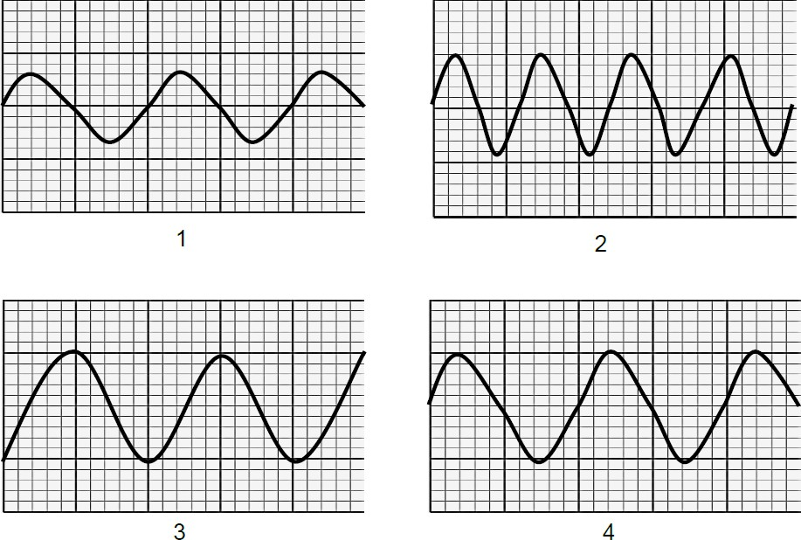
- 1 and 2
- 1 and 3
- 1 and 4
- 2 and 4

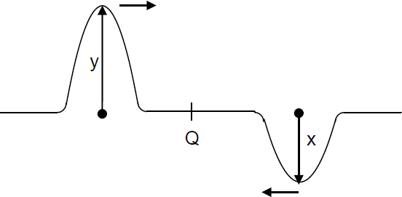

1.3 | Two pulse are traveling towards each other along a string, as shown in the diagram below. | (2)
A | x+y
B | 2(x+y)
C | y-x
D | 2(y-x)
1.4 | A wave in which the particles of the medium vibrate at right angles to the path along which the wave travels through the medium, is produce by… | (2)
A | A bat
B | A car’s hooter
C | An ambulance
D | An X-ray machine
1.5 | The number of waves passing a point every second is define as the…of the wave. | (2)
A | Speed
B | Amplitude
C | Wavelength
D | Frequency

LONG QUESTIONS QUESTION 2
Study the following diagram and answer the questions:
Identify two sets of points that are in phase
Identify two sets of points that are in phase.
Identify any two points that would indicate a wavelength
Identify any two points that would indicate a wavelength.
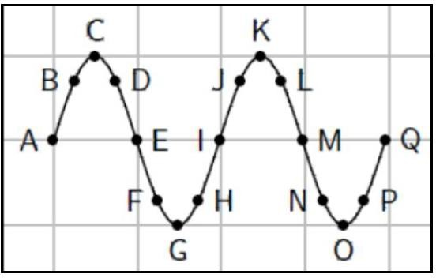

 | QUESTION 3
 | Water waves crash against a seawall around the harbour. Eight waves hit the seawall in 5s. The distance between successive troughs is 9 m. The height of the wave from trough to crest is 1,5 m.
3.1 | How many complete waves are indicated in the sketch?
3.2 | Write down the letters that indicate any TWO points that are:
3.2.1 | In phase
3.2.2 | Out of phase
3.2.3 | Represent ONE wavelength
 | A. Calculate the amplitude of the wave.
 | B. Show that the period of the wave is 0,67 s.
3.2.4 | Calculate the frequency of the waves.
3.2.5 | Calculate the velocity of the waves.
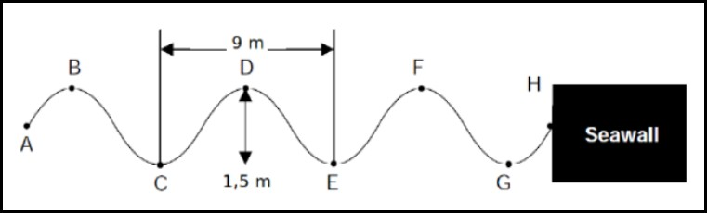

QUESTION 4
You are given the transverse wave below:
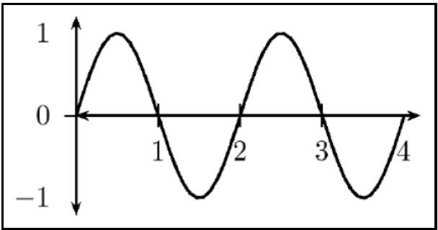

Draw the following:
  - A wave with TWICE the amplitude of the given wave.
  - A wave with HALF the amplitude of the given wave.
  - A wave travelling at the same speed with TWICE the frequency of the given wave.
  - A wave travelling at the same speed with HALF the frequency of the given wave
  - A wave with TWICE the wavelength of the given wave.
  - A wave with HALF the wavelength of the given wave
  - A wave travelling at the same speed with TWICE the period of the given wave.
  - A wave travelling at the same speed with HALF the period of the given wave.

QUESTION 5

A wave travels along a string at a speed of 1, 5m · s−1. If the frequency of the source of the wave is 7,5 Hz, calculate:
  - The period of the wave. (3)
  - The wavelength of the wave. (4)

 | QUESTION 6
A heavy rope is flicked upwards, creating a single pulse in the rope.
Make a drawing of the rope and indicate the following in your drawing:
6.1 | The direction of motion of the pulse
6.2 | Amplitude
6.3 | Pulse length
6.4 | Position of rest
6.5 | A pulse has a speed of 2, 5m · s−1. How far will it have travelled in 6 s?
 | SOUND WAVES QUESTION 7
Four options are provided as possible answers to the following questions. Each question has only ONE correct answer. Choose the answer and write only the letter (A–D) next to the question number (7.1–7.4) in the ANSWER BOOK, for example 1.3
C
7.1 | Which ONE of the combinations below concerning the pitch and loudness of sound is CORRECT?  The pitch and loudness of sound depend on:
PITCH LOUDNESS

- Frequency Amplitude of vibration
- Frequency Speed of vibration C Amplitude of vibration Frequency
D Speed of vibration Frequency
7.2 | A wave in which the particles of the medium vibrate at right angles to  the direction in which the wave travels through the medium, is produced by …
A | Bat.

B | A car’s hooter
C | An ambulance
D | an X-ray machine

 | QUESTION 8
Learners are investigating the effect sound waves have on each other. They connect two speakers, which are several meters apart, to a signal generator and play the same signal with a single frequency through both speakers. One of the learners walks from speaker 1 to speaker 2,
while listening carefully to the sound. At point A between the speakers, the learner observes that the sound is LOUDER than at any other point at either side of point A.
8.1 | What type of wave is a SOUND wave?
8.2 | Consider the following statement: The addition of two pulses that occupy the same space at the same moment.  Which PRINCIPLE is referred to here?
8.3 | On an oscilloscope, pulses from speaker 1 and speaker 2 are as illustrated below.
8.3.1 | Draw the wave pattern that will appear on the oscilloscope the moment the two pulses reach point A simultaneously. The drawing does not have to be to scale, but the magnitude of the amplitude of the pulse at A must  be indicated on the drawing.
8.3.2 | Identify the phenomenon in QUESTION 8.3.1.
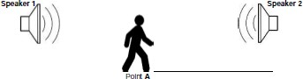
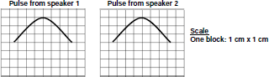

9
9.1 | Define the term longitudinal wave.
9.2 | A sound wave travels to a high wall which is 225 m away from the source and is then reflected back.  If the speed of sound in air is 340 m∙s-1, calculate the time it takes to hear  the echo.
The same sound source used in QUESTION 2.2 above is used to
produce an echo by sending the sound into water.
9.3 | Is the time it takes to hear the echo LESS THAN, EQUAL TO or THE SAME as that obtained in QUESTION 9.2? Give a reason for the answer.
10 | Study the wave pattern. It takes 0.3s to complete the pattern from A to H.
10.1 | Define the term amplitude
10.2 | Explain the difference between a period and frequency
10.3 | Name any two points that are in phase.
10.4 | Determine the wavelength of the wave
10.5 | What is the amplitude of the wave?
10.6 | What is the period of the wave?
10.7 | Calculate the frequency of the wave
10.8 | Calculate the speed of the wave
10.9 | Determine how long it will take the wave to travel a distance of 20m
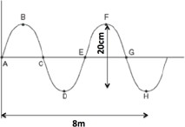

KZN PHYSICAL SCIENCES SUPPORT DOCUMENT GRADE 10
2020

ELECTROMAGNETIC RADIATION
 | QUESTION 1
1.1 | Consider the following statement concerning ultraviolet radiation :
 | (i) It cannot be reflected
 | (ii) It has a longer wavelength than gamma rays
 | (iii) It is radiated from the sun and the sun may be harmful to humans.
 | Which ONE of the following combinations is CORRECT?
 | A (i) and (ii) only
 | B (ii) and (iii) only
 | C (i) and (iii) only
 | D (i) , (ii) and (iii)
1.2 | Red light of frequency f and a wavelength λ shines on an object. The red light is then replaced by light of higher energy. How do the frequency and the wavelength of light shining on the object now compare with that of red  light?
FREQUENCY WAVELENGTH
- Greater than f Remains the same(λ)
- Less than f Greater than λ
- Greater than f Less than λ
- Remains the same(f) Less than λ
1.3 | The frequency of a wave is defined as the…
 | A Lowest point on a wave.
 | B Time taken for one complete wave.
 | C Number of complete waves per second.
 | D Number of points in phase in a wavelength.

  - Which type of wave DOES NOT travel at 3x108m.s-1?
A. Radio
B Gamma C Sound
D Microwaves

QUESTION 2 (LONG QUESTIONS)
The table below shows an arrangement of electromagnetic radiation according to their frequencies.
TYPE OF RADIATION | TYPE OF FREQUENCY(Hz)
Radio waves | 105 - 1010
Micro waves | 1010 -1011
Infrared(IR) | 1011 -1014
Visible light | 1014 -1015
Ultra violet(UV) | 1015 -1016
X-rays | 1016 -1018
Gamma rays | 1018 - 1021

  - Write down TWO properties of electromagnetic waves.
  - Which radiation has the highest energy?
A certain radiation has energy of 1. 99 x 10 -20 J.
  - Identify the type of radiation associated with this energy.

2.4 | Refer to diagrams A to C below.
 | Which type of radiation is used:
 | A
 | B
 | C
 | QUESTION 3
The types of electromagnetic radiation are arranged according to
frequency in the table below
TYPE OF RADIATION FREQUENCY(HZ)
Radio waves 105 - 1010
Micro waves 1010 - 1011
Infrared 1011 - 1014
Visible light 1014 - 1015
Ultraviolet 1015 - 1016
X-rays 1016 - 1018
Gamma rays 1018 - 1021
3.1 | How are electromagnetic waves generated?
3.2 | What type of electromagnetic radiation has the highest energy?
3.3 | Explain the answer to QUESTION 3.2
3.4 | A certain type of electromagnetic radiation has a wavelength of  600 x 10-10m
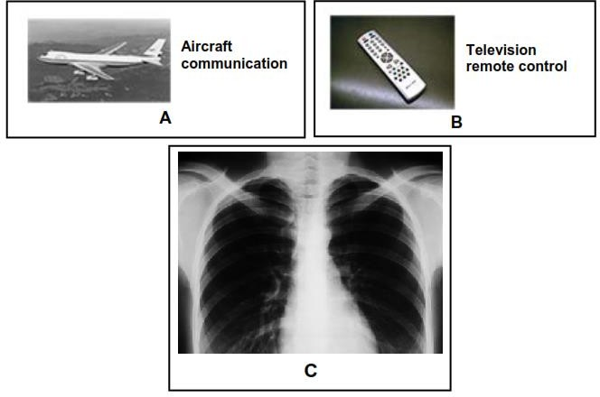

KZN PHYSICAL SCIENCES SUPPORT DOCUMENT GRADE 10
2020

3.4.1 | Identify the type of electromagnetic radiation by performing a Calculation
3.4.2 | State ONE application of the type of radiation identified in QUESTION 3.4.1
 | QUESTION 4
The frequency and corresponding energy of electromagnetic waves are
given in the table below.
WAVE FREQUENCY(Hz) ENERGY(J)
A 2 x 109 1.33 x 10-24
B 4 x 1012 2.65 x 10-21
C 3.5 x 1015 2.32 x 10-18
D 1.8 x 1018 1.19 x 10-15
E f 4.97 x 10-15
4.1 | Describe how an electromagnetic wave propagates
4.2 | What is the relationship between frequency and energy of electromagnetic  wave, as shown in the table above?
4.3 | Calculate the:
4.3.1 | Frequency of wave E
4.3.2 | Wavelength of wave D
4.4 | Which wave, A or B, has the HIGHER penetrative ability? Give a reason for the answer.

Definitions and Terminology
A medium is the substance or material in which a pulse will move.
A pulse is a single disturbance in a medium.
Rest or equilibrium position is the position a medium would be in if it were
not disturbed.
A crest is the highest point on a wave.
A trough is the lowest point on a wave.
A vibration is a to-and-fro motion.
An oscillation is a vibration.
A transverse pulse is a pulse in which the particles of the medium move at
right angles to the direction of the motion of the pulse.
Amplitude is the maximum disturbance of a particle from its rest position or
equilibrium position.
Superposition is the algebraic sum of the amplitudes of two pulses that
occupy the same space at the same time.
Constructive interference is the phenomenon where the crest of one pulse
overlaps with the crest of another pulse to produce a pulse of increased amplitude.
Destructive interference is the phenomenon where the crest of one pulse overlaps with the trough of another pulse resulting in a pulse of reduced
amplitude .
A wave is a periodic, continuous disturbance that consists of a train or series
of pulses.
A transverse wave is a wave in which the particles of the medium vibrate at
right angles to the direction of motion of the wave.
Frequency is the number of waves per second.
Period is the time taken for one complete wave pulse.
Two points in phase are separated by a whole number multiple of complete
wavelengths.

Two points out of phase are not separated by a whole number multiple of complete wavelengths.
Wave speed is the distance travelled by a point on a wave per unit time.
A longitudinal wave is a wave in which the particles of the medium vibrate
parallel to the direction of motion of the wave.
Wavelength is the distance between two successive points in phase.
A compression is a region of high pressure in a longitudinal wave.
A rarefaction is a region of low pressure in a longitudinal wave.
Pitch is the effect produced in the ear due to the sound of a particular
frequency.
Loudness is the strength of the ear’s perception of a sound.
Ultrasound is sound of frequencies higher than 20 kHz up to 100 kHz.
Electromagnetic Radiation
An electromagnetic wave is a wave that propagates when an electric field oscillating in one plane produces a magnetic field oscillating in a plane at right
angles to it, which produces an oscillating electric field.
The dual nature of electromagnetic radiation – some aspects of
electromagnetic radiation can best be explained using a wave model and some aspects can best be explained by using a particle model.
A photon is a packet of energy.

MATTER AND MATERIALS
Topic: Matter and classification of matter
Revision(grade 9)
Matter: Anything that occupies space and has mass.
Describe matter as being made up of particles whose properties determine the observable characteristics of matter and its reactivity. (from exam guidelines)
Physical Properties of materials
- Strength: the ability of a material to resist stress and strain
- Thermal conductivity: the ability of material to conduct heat
- Electrical conductivity: the ability of a material to conduct electricity
- Brittle: hard but likely to break
- Malleable: Ability to be hammered or pressed into shape without breaking or cracking
- Ductile: the ability to be stretched into a wire
- Magnetic: a material which can be attracted or repelled by a magnet (its domains are aligned)
- Non-magnetic: a material which is not attracted or repelled by a magnet (its domains are misaligned)
- Density: the mass per unit volume of a substance
- Melting point: The temperature at which a solid becomes a liquid.
- Boiling point: the temperature of a liquid at which its vapour pressure equals the external (atmospheric) pressure

Atom (Revision grade 9): It is a basic building block of all matter.

- Pure Substance: A substance that cannot be separated into simpler components by physical methods e.g. Pure copper, oxygen
- Element: Pure substance consisting of only one type of atom e.g Argon, mercury, silicon, gold
- Compound: Pure substance consisting of two or more elements Chemically bonded in a fixed ratio e.g Water, carbon dioxide, Sodium chloride.
- Mixture: Consists of different particles mixed together, but not chemically joined. Milk, air, salt water
- Homogenous mixture : A mixture of uniform composition and in which all components are in the same phase E.g.: air, brine, steel
- Heterogeneous mixture: A mixture of non-uniform composition and of which the components can be easily identified e.g. Sand and rock mixture, Pizza toppings

- Atoms combine in very specific ratios to form certain compounds
- e.g., carbon dioxide consists of 1 carbon and 2 oxygen atoms.
- These ratios remain fixed for that compound. The ratio is given by the formula. e.g. CO2

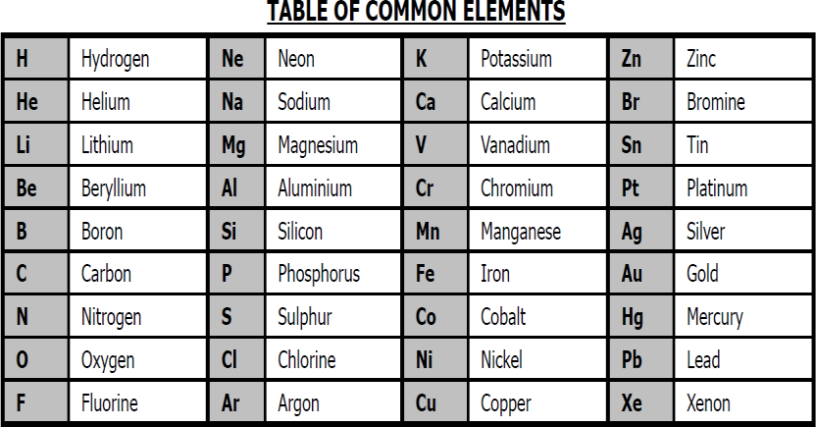
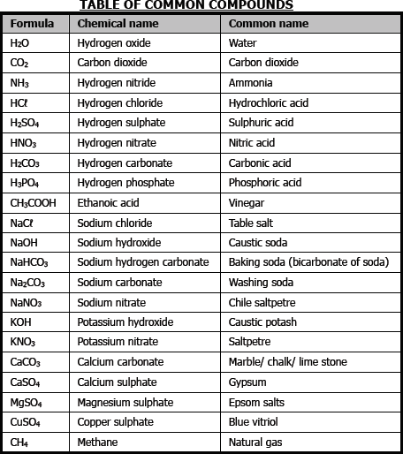
    - An ion: is a charged particle made from an atom by the loss or gain of electrons.
    - An anion (negative ion): is a charged particle made from an atom by the gain of electrons
    - A cation (positive ion): is a charged particle made from an atom by the loss of electrons

- Simple ions are single atoms, which carry a charge.
- They are also called monatomic ions. E.g. H+ ; Cl-; Mg2+
- Polyatomic ions are groups of atoms bonded together which collectively carry a charge.
WRITING CHEMICAL FORMULAE
Follow these basic steps to write chemical formulae for ionic substances:
- Write symbol for the positive ion first, then for the negative ion.
The ions could be monatomic ions or polyatomic ions.
- Write ionic charges at top right of symbols
Monatomic ion → the ion of one single element only, so you can use periodic table to determine the charge.
Polyatomic ion → you must memorize the charges.
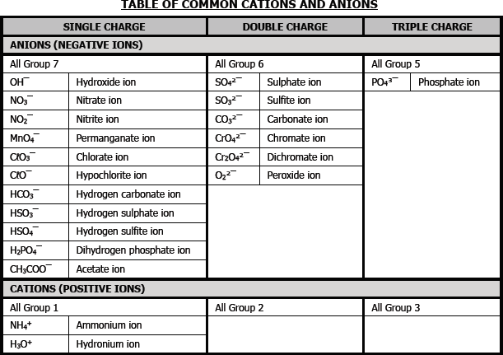

“Cross multiply” the numbers so that the total charge of the compound is 0.
- Write final compound:
- ends in –ide → monatomic ion
E.g. Hydrogen Sulphide = H2S
- the name ends in –ate or –ite if it includes oxygen
- Roman numerals (II) → ionic charge of the metal
E.g. Copper(II)sulphate → CuSO4

EXAMPLE:
Aluminum chloride
Aℓ3+ O2- (“cross-multiply” numbers)
Aℓ 2O3 (the total charge must be zero) i.e. 2(+3)+3(-2) = 0

Metals, metalloids and non-metals

- Metals and non-metals
- Most, but not all metals and non-metals have the following properties:

Metals | Non metals
Solids at room temperature  (except mercury) | Solids, liquids and gases at  room temperature
Malleable | Brittle
Ductile | Poor conductors of electricity- good insulator, except in the form of graphite, which conduct  electricity well
Conductors of electricity | Poor thermal(heat)conductors
Heat conductors
Sonorous i.e.
(rings when struck)

New surfaces have a luster i.e shiny
Hard Strong
- Metalloids: are elements that have both properties of metals and non-metals but mainly non-metallic
- The following can be considered as metalloids:
o boron(B), silicon(Si), Germanium(Ge), Arsenic(As), antimony(Sb), Tellerium(Te), Polonium(Po) and Astatine(At)
Matter and classification: Electrical conductors, semi-conductors and insulators
Another way of classifying matter is as electrically conducting, semi conducting or insulating.
- All metals are conductors of electricity
- Metals electrical conductivity decreases with increasing temperature.
- Metals that are good conductors of electricity can be used as
conducting wires.
  - Silver is the best conductor, but too expensive to use in transmission lines.
  - Copper is almost as good as silver, copper is used instead.
  - Although aluminum has a slightly higher resistance, its density is much less than that of copper and therefore transmission lines are often made of aluminium.
  - Metals that conducts electricity, but have a high
resistance, eg tungsten or nichrome (alloy of nickel, iron

and chromium), can be used as heating elements in electric kettles, Irons, heaters, etc.
- Most non-metals are not conductors of electricity and can be used as insulators. (except graphite)
- Some of the metalloids, such as silicon and germanium, are semi- conductors
  - Their conductivity increases with increasing temperature. The reverse of metals.
  - They can be used in diodes in computers and other electronic equipment
Matter and classification: thermal conductors and insulators
- Matter can be classified as thermally conducting or insulating.
- In general, metals are good conductors of heat. Silver is best, followed by copper, aluminium, steel.
- Non-metals are poor conductors and thus good insulators, e.g. asbestos, wood, air.
Matter and classification magnetic and non-magnetic materials
- Examples of magnetic substances:
- Metals iron, cobalt and nickel these metals are classified as
ferromagnetic materials
- The use of magnets in daily life(in speakers, in telephones, electric motor, as compasses)

States of matter and the kinetic molecular theory
STATES OF MATTER
All matter has mass and takes up space (volume).

- Matter occurs in one of three states, solid, liquid or gas, depending on the temperature.
- The state of matter depends on its melting point (MP) and boiling point (BP). If the temperature is below the MP, it is a solid. If the temperature is above the MP, but below the BP, it is a liquid. If the temperature is above the BP, it is a gas.
- Diffusion: The movement of atoms or molecules from an area of higher concentration to an area of lower concentration.
- Brownian motion: The random movement of microscopic particles suspended in a liquid or gas, caused by collisions between these particles and the molecules of the liquid or gas.
Characteristics of the three states of matter
- Boiling point: The temperature of a liquid at which its vapour pressure equals the external (atmospheric) pressure.
- Melting point: The temperature at which a solid, given sufficient heat, becomes a liquid.
- Freezing point: The temperature at which a liquid changes to a
solid by the removal of heat
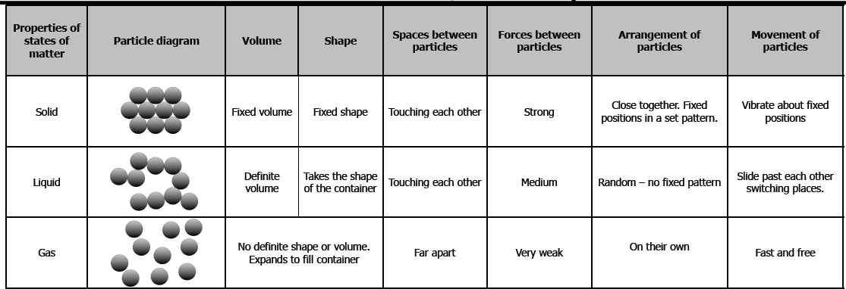

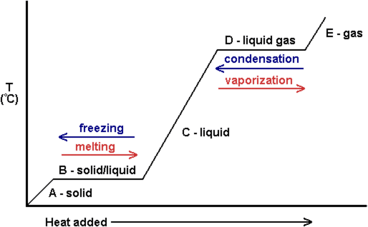

Heating and cooling curve of water
Define melting, evaporation, freezing, sublimation and condensation as changes in state.
- Melting: The process during which a solid changes to a liquid by the application of heat.
- Evaporation: The change of a liquid into a vapour at any temperature below the boiling point. (Note: Evaporation takes place at the surface of a liquid, where molecules with the highest kinetic energy are able to escape. When this happens, the average kinetic energy of the liquid is lowered, and its temperature decreases.
- Freezing: The process during which a liquid changes to a solid by the removal of heat.
- Sublimation: The process during which a solid changes directly into a gas without passing through an intermediate liquid phase.
- Condensation: The process during which a gas or vapour changes
to a liquid, either by cooling or by being subjected to increased pressure.

KINETIC MOLECULAR THEORY
- All matter is made of tiny particles with spaces in between them.
- The tiny particles are constantly moving, but the particles lose no kinetic energy when they collide with other particles or with the walls of their container.
- The kinetic energy of the particles depends on how fast they are moving; at any given time, some particles are moving slowly while others are moving fast.
- The temperature is a measure of the average kinetic energy of the particles.
- The potential energy of the particles depends on how far they are apart and depends on their state (solid, liquid or gas).
- There are attractive forces between the particles, which become
stronger as the particle move closer.

ATOMIC STRUCTURE
- Atomic number : is the number of protons in an atom of an element.
- Atoms are the very small particles of which all elements are made- they are the basic building block of all matter – including your own body, your hair, your organs, the earth, the sun are all made of different combinations of atoms. E.g. Your body is made of 65% Oxygen, 19% Carbon and 10% Hydrogen by mass.
- All known elements are arranged on the periodic table in order of increasing atomic number.
- Periodic refers to ‘repeating patterns.’ Elements are arranged into groups (vertical columns) and periods (horizontal rows).
- Elements in within a group have similar physical and chemical properties.
- Atomic theory is the basis for understanding the interactions and
changes in matter.
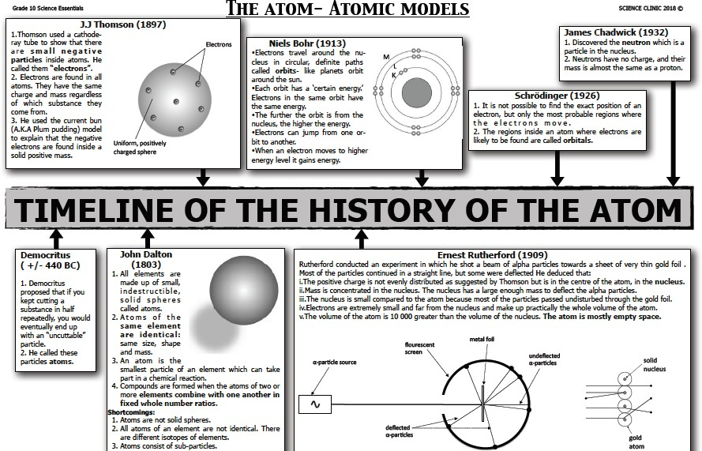

ATOMS AND SUB-ATOMIC PARTICLES
- Three subatomic particles are found inside the atoms, i.e. protons, neutrons and electrons.
- The nucleus is in the centre of the atom and contributes most of the mass.
- The nucleus is made of the protons and neutrons which are called nucleons; because subatomic particles have extremely small masses, the atomic mass unit amu is used.1 amu = 1,677 × 10−27 kg.
- The mass of an atom is measured relative to the mass of carbon-12 atom.
- Carbon-12 is exactly 12 amu, therefore 1 amu is one-twelfth the
mass of carbon-12 atom

Atomic Number (Z) and Atomic Mass (A)
- An atom is identified by the contents of its nucleus.
- An atom is represented by the notation:

A
E
Z
- E represents the symbol of the element
- A Atomic Mass (A) is the number of nucleons
- Z Atomic Number (Z) is the number of protons
- Elements in the periodic table are arranged in order of increasing atomic number (Z).
- The number of protons (Z) gives each element its unique properties.
- Z also indicates how many electrons are present in the atom as
the atom electrically neutral.

- A indicates the mass of the atom how many nucleons are present in the atom.
- Number of neutrons = Atomic mass number - Number of protons (N = A - Z)
24
Mg
12
- e.g. atomic number: 12
- no of protons : 12
- number of electrons: 12
- number neutrons : (24-12=12)
12
C
6
- e.g. atomic number: 6
- no of protons : 6
- Number of electrons: 6
- Number neutrons: (12-6=6)

24
Mg2+
12
- e.g. atomic number: 12
- no of protons : 12
- number of electrons: 10
- number neutrons : (24-12=12)
STRUCTURE OF AN ATOM-ISOTOPES

- Isotopes: Atoms of the same element having the same number of protons, but different numbers of neutrons.
- Relative atomic mass: The mass of a particle on a scale where an atom of carbon-12 has a mass of 12.
- Calculate the relative atomic mass of naturally occurring elements from the percentage of each isotope in a sample of the naturally occurring element and the relative atomic mass of each of the isotopes.
- Represent atoms using the notation where E is the symbol of the element, Z is the atomic number and A is the mass number.
ATOMIC STRUCTURE (ELECTRON CONFIGURATION)
ELECTRON ARRANGEMENT IN THE ATOM
- In neutral atoms, the number of electrons in the cloud around the nucleus equals the number of protons in the nucleus.
- The electrons closer to the nucleus have less energy than the electrons further away from the nucleus.
- The electrons occur in energy levels (n).
- Different energy levels are able to accommodate different numbers of electrons (Total electrons = n2).
- The electrons are found in certain regions within an energy level, referred to as orbitals.
a. Each orbital can accommodate 2 electrons.
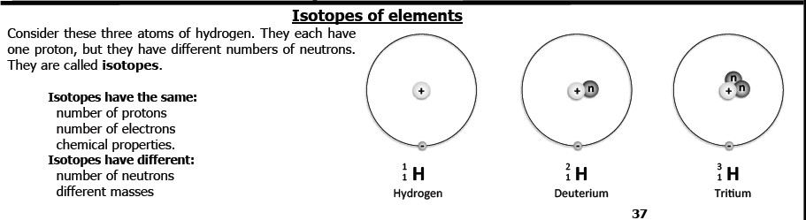

- Electrons are always found in positions of lowest possible energy (as close to the nucleus as possible)
- energy level 1: 1 s orbital
- energy level 2: 1 s and 3 p orbitals
- energy level 3: 1 s, 3 p and 5 d orbitals

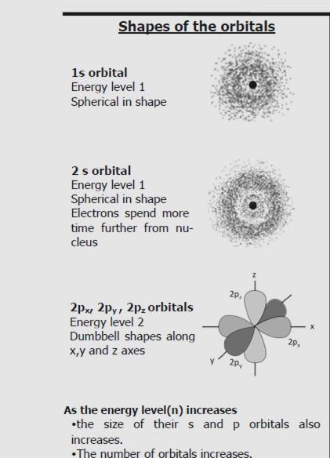

- F = 1s2 2s2 2p5
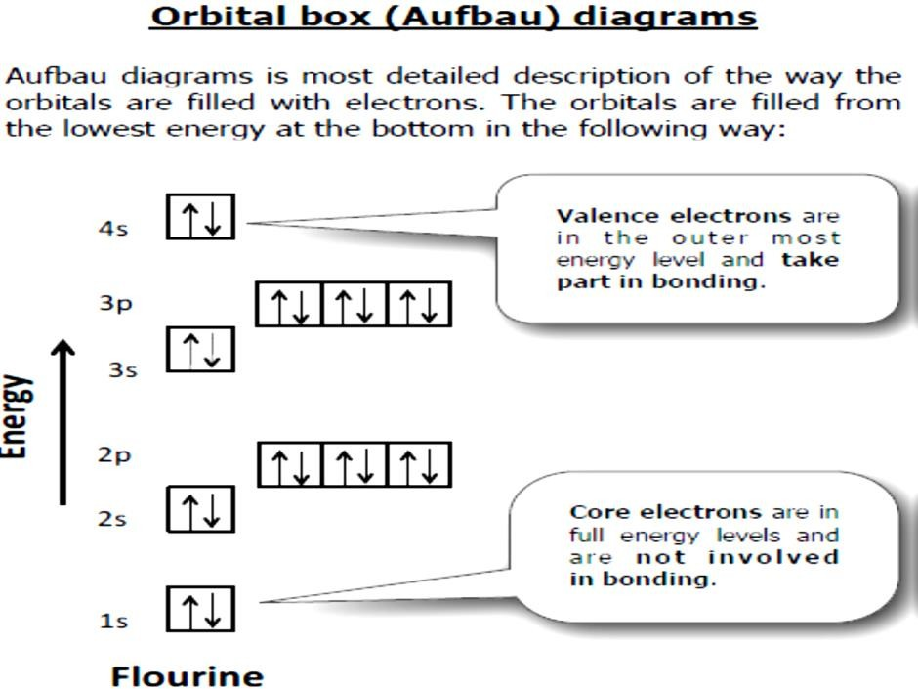

- State Hund's rule: No pairing in p orbitals before there is not at least one electron in each of them.
- State Pauli's Exclusion Principle: Maximum of two electrons per orbital provided that they spin in opposite directions.

Periodic Table
- Describe the periodic table as displaying the elements in order of increasing atomic number and showing how periodicity of the physical and chemical properties of the elements relates to atomic structure.
- Groups are the vertical columns in the periodic table. Some groups have names, e.g. alkali metals (group I), earth-alkaline metals (group II), halogens (group 17 or VII) and noble gases (group18 or VIII).
- Periods are the horizontal rows in the periodic table.
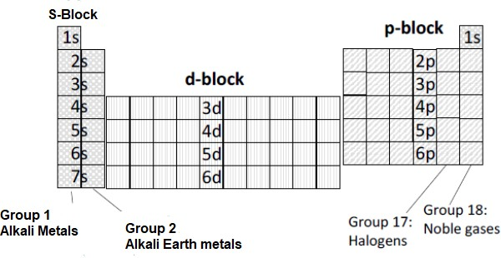
- Atomic radius: Radius of an atom, i.e. the mean distance from the nucleus to the border of the outer orbital.
- Atomic radii decrease across a period because as electrons are being added to the same energy level, protons are being added to the nucleus, which pulls the electrons with a stronger force.
- Atomic radii increase down a group because
  - electrons enter a whole new energy level in the next period
  - The core electrons shield the outer electron from the pull of the nucleus.

- Ionization energy: Energy needed per mole to remove an electron(s) from an atom in the gaseous phase.
- First ionization energy: Energy needed per mole to remove the first electron from an atom in the gaseous phase.
- The smaller the atom, the more the force of attraction by the nucleus on the outer electron, hence the higher the ionization energy.
  - IE increases across a period
  - IE decreases down a group
- Electron affinity: The energy released when an electron is attached to an atom or molecule to form a negative ion.
- The electron affinity is also a description of how likely an atom is to accept an electron
- The smaller the atom, the greater the ability of an atom to receive
an electron due to proximity to the nucleus.
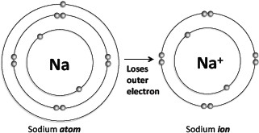
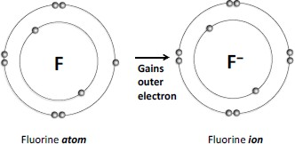

- EA increase across a period
- EA decreases down a group
- Electro negativity: A measure of the tendency of an atom in a molecule to attract bonding electrons.
- Electronegativity range from 0,7 (Cs) to 4,0 (F).
  - EN increases across a period
  - EN decreases down a group
CHEMICAL BONDING
- Chemical bond is a mutual attraction between two atoms resulting from the simultaneous attraction between their nuclei and outer most electrons.
- Chemical bond occurs when attractive forces hold atoms.
- There are three types of bonds: Covalent bonds, ionic bonds, and metallic bonds.
  - None metals + none metals → Covalent bond
  - None metals + metals → ionic bonds
  - Metal + metal → metallic bond
What happens when atoms bond?
- This attraction occurs when electrons are shared between atoms, or when electrons are exchanged between the atoms that are involved in the bond.
- The sharing or exchange of electrons takes place so that the outer energy levels of the atoms involved are filled and the atoms are more stable.
- If an electron is shared, it means that it will spend its time moving in
the electron orbitals around both atoms.

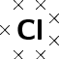
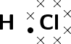
- If an electron is exchanged it means that it is transferred from one atom to another, in other words one atom gains an electron while the other loses an electron.

LEWIS STRUCTURE
- Lewis notation uses dots and crosses to represent the valence electrons on different atoms.
- The chemical symbol of the element is used to represent the nucleus and the inner electrons of the atom. To determine which are the valence electrons we look at the last energy level in the atom's electronic structure.
TIP:
- If we write the condensed electron configuration, then we can easily see the valence electrons
For example:

- A hydrogen atom (one valence electron) would be represented like this:
- A chlorine atom (seven valence electrons) would look like this:
- A molecule of hydrogen chloride would be shown like this:
- The dot and cross in between the two atoms, represent the pair of electrons that are shared in the covalent bond.

Examples of Lewis diagrams

Iodine | I2 | 
Water | H2O | 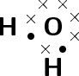
Carbon dioxide | CO2 | 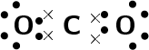
Hydrogen cyanide | HCN | 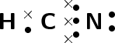

Covalent Bonding

- Covalent bond is a sharing of electrons between atoms to form molecules.
- Molecule: A group of two or more atoms that are covalently bonded and that functions as a unit.
- Covalent bonding occurs between the atoms of non –metals.
- Strong electrostatic forces of attraction hold electrons together.
- Atoms bond covalently so that they may form a molecule with a lower potential energy state
- Each of the two bonding atoms must have half-filled orbitals

- Sharing of electrons occurs by the overlap of two half-filled orbitals to form a new filled orbital
- The electrons which are shared must have opposite spins (Pauli’s Exclusion Principle)
- Covalent bond are formed between atoms that have the same or a small difference in electronegativity.
Covalent bonding in a molecule of hydrogen chloride
Single covalent bond:
- Formed when two electrons are shared between the same two atoms (one electron from each atom).
Double covalent bond:
- Formed when four electrons are shared between the two atoms (two electrons from each atom).
A double covalent bond in an oxygen molecule
Triple covalent bond
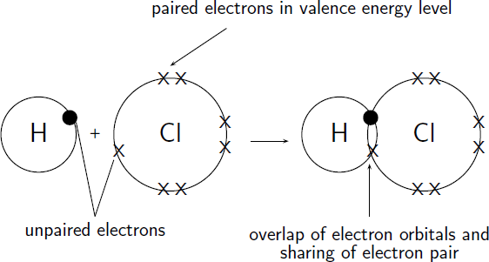
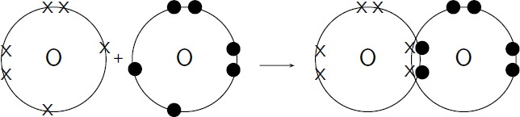

Formed when six electrons are shared between the same atoms (three electrons from each atom).

EXAMINATION TYPE QUESTIONS
1 | From the list below, choose the label best suited to each picture that follows. Labels may be used more than once.  - element  - mixture of compounds  - compound  - mixture of elements and compounds  - mixture of elements
 | 1.1 |  | (1)
 | 1.2 |  | (1)
 | 1.3 |  | (1)
 | 1.4 |  | (1)
2. |  | In each case, determine if the substance is PURE, or if it is a HOMOGENEOUS or HETEROGENEOUS MIXTURE
 | 2.1 | soda water | (1)
 | 2.2. | coffee with milk and sugar | (1)
 | 2.3. | carbon dioxide gas | (1)
 | 2.4. | oil and vinegar | (1)
 | 2.5. | concrete | (1)
 | 2.6. | concentrated swimming pool acid | (1)
 | 2.7. | copper | (1)
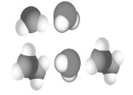
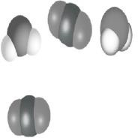
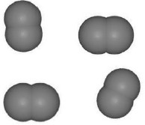
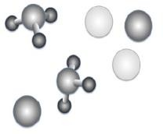

2.8. | sugar mixed with sand | (1)
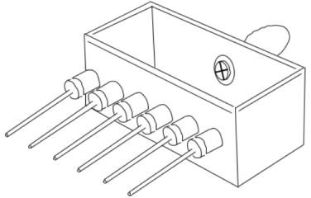

3 | In order to study the thermal conductivity of different materials, learners choose to use a Ingenious Conductivity Apparatus.  The apparatus, shown below, has a container where boiling water is poured into and rods of different material types attached.
Learners use Vaseline to secure a thumb-tack on the end of each rod. When hot water is poured into the container, the heat is transferred through the rods, melting the Vaseline. The learners record the time taken for the thumb-tack to fall of the end of the rod, indicating that heat has reached the end of the
rod. The results obtained were tabulated below:
Material Time taken (s)
Copper 62
Aluminium 87
Stainless steel 147
Lead 105
Graphene 45
Wood No result
3.1. | Name the following variables for this experiment: | (1)
 | 3.1.1. Dependant | (1)
 | 3.1.2. Independent | (1)
 | 3.1.3. Controlled | (1)
 | 3.1.3. Explain the concept of thermal conductivity. | (2)

 |  | 3.1.4. Rank the materials from most to least thermal conductive. | (3)
 | 3.2 | The learners noticed that the wood did not warm up on the end, and therefore no result was obtained.  What name is given to materials that do not allow heat energy to flow through it? | (1)
4 | Mixtures are separated using various separation techniques.
Use the list of separation methods below and answer the questions that follow:
Chromatography; decanting; separating funnel; fractional distillation; evaporation;
filtration.
 | 4.1. | What is a homogenous mixture? | (2)
 | 4.2. | Using the list, name 3 methods suitable for the separation of a  homogenous mixture? | (2)
 | 4.3. | What is a heterogeneous mixture? | (2)
 | 4.4 | Using the list, name 3 methods suitable for the separation of a  heterogeneous mixture? | (3)
 | 4.5. | State the name of the separation method illustrated in the  image below | (4)

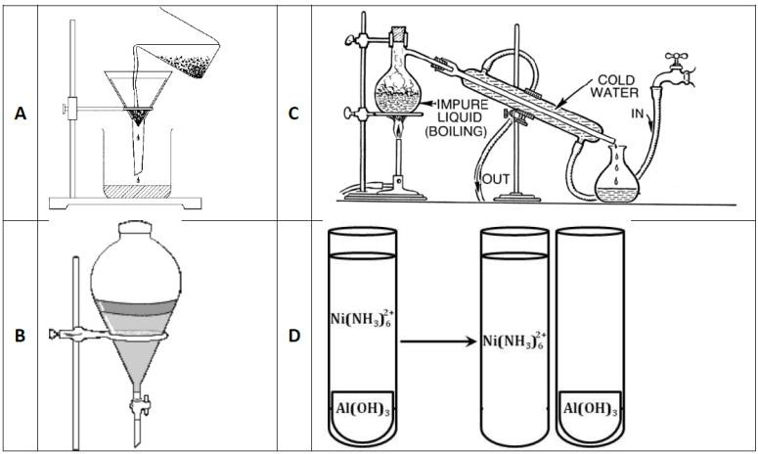

5.1 | Write down the chemical name for each of the following  compounds.
 | 5.1.1. | NH3 | (2)
 | 5.1.2. | HNO3 | (2)
 | 5.1.3. | H2SO4 | (2)
 | 5.1.4. | Pb(NO3)2 | (2)
 | 5.1.5 | K2Cr2O7 | (2)
5.2 | Write down the formula for each of the following compounds/ions
 | 5.2.1. | sodium sulphite | (2)
 | 5.2.2. | mercuric oxide | (2)
 | 5.2.3. | ammonium sulphate | (2)
 | 5.2.4 | hydroxide ion | (2)
 | 5.2.5 | carbonate ion | (2)

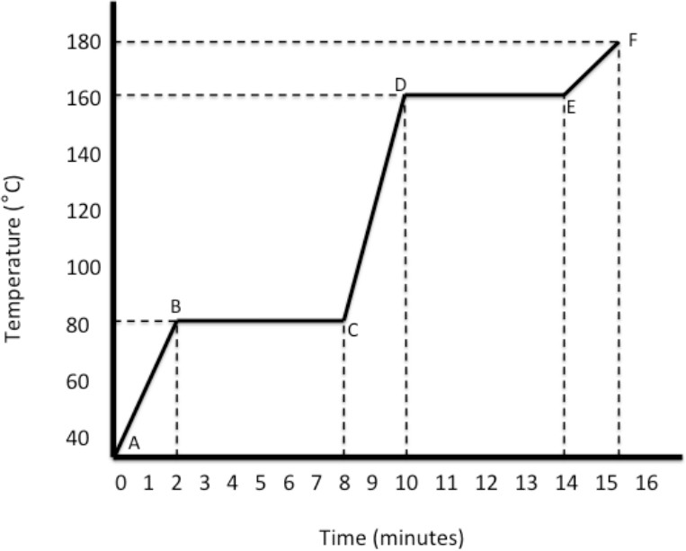
6
 | Description | Metal, metalloid or  non-metal
6.1 | form anions through  electron gain
6.2 | poor conductors of heat and  electricity
6.3 | malleable and ductile
6.4 | Forms metallic bonds
6.5 | Electrical conductivity  increases with temperature

(1)

(1)
(1)
(1)

(1)

7 | Use the graph below to answer the questions that follow:
 | At which point (or between which points) on the graph
7.1 | does the substance have no definite shape and the molecules | (1)

 | are moving freely?
7.2 | does the substance have a fixed shape? | (1)
7.3 | is there no change in kinetic energy? | (1)
7.4. | does the substance undergo evaporation? | (1)
7.5. | is the substance in both the solid phase and the liquid phase? | (1)
7.6. | do the molecules have the highest average kinetic energy? | (1)
7.7 | Now answer the following additional questions from the above graph:
 | 7.7.1. What is the boiling point of the substance? | (1)
 | 7.7.2. What is the melting point of the substance? | (1)
 | 7.7.3. How long does it take for the substance to change from  a solid to a liquid? | (1)
 | 7.7.4. How long does the beaker contain some of the  substance in liquid form? | (1)
7.8 | Copy and complete the diagram by adding the names of the missing processes and drawing sketches as directed.
 | 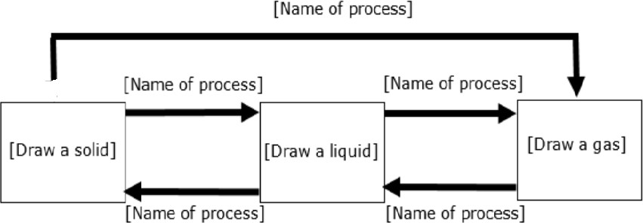
 |  | [8]

8 | Nitrogen occurs in nature as two stable isotopes:  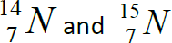  Old Paul Roos student Stefan Meiring Naude discovered the nitrogen-15 isotope. The majority of the nitrogen in nature is nitrogen-14 and the nitrogen-15 isotope is often used in  medical research.
8.1. | Provide the Aufbau Diagram of Nitrogen. | (2)
8.2. | Suppose that the nitrogen-14 isotope occurs 90% of the time in nature and that the Nitrogen-15 isotope occurs only 10% of the time. Calculate the  relative atomic mass of Nitrogen.
 |  | (4)
8.3. | Will the chemical properties of Nitrogen-14 and Nitrogen-15  differ from each other? Give a reason for your answer.
 |  | (2)
8.4. | What is the valency of nitrogen? | (1)
8.5 | Oxygen is a non-metallic element with an atomic number of 8  and can exist as isotopes.
 | Define the term:
 | 8.5.1 Atomic number | (2)
 | 8.5.2 Isotope | (2)
8.6. | Natural oxygen has 2 abundant stable isotopes  16 18  O O  8 8
 | 8.6.1. Write down the sp-notation for O-18 | (2)
 | 8.6.2. If the relative atomic mass of oxygen is 16,04.  Calculate percentage of O-16 in natural oxygen. | (5)

8.7 | Oxygen gas (O2) consists of molecules. Write down the:
 | 8.7.1. Number of valence electrons in an oxygen atom. | (1)
 | 8.7.2. Type of bonding in oxygen molecules. | (1)
 | 8.7.3. Lewis structure for the oxygen molecule. | (2)
8.8. | Calcium reacts with oxygen to form calcium oxide
 | 8.8.1. Draw the Aufbau diagram for a calcium ion. | (2)
 | 8.8.2. Write down the chemical symbols of the particles found in calcium. | (1)
9. | The atoms of two elements P and Q are represented below:  P: 1s22s22p2 Q: 1s22s22p4
9.1 | Identify the elements P and Q. | (2)
9.2 | What type of chemical bond forms when P combines with Q? | (1)
9.3. | Draw Lewis structures to show the formation of the bond  between P and Q. | (3)
9.4. | What type of chemical bond forms when Q combines with  potassium metal? | (1)
9.5. | Write the name of the compound that forms when Q combines  with potassium metal. | (2)
9.6. | Draw the energy level diagram (Aufbau diagram) for the  aluminium ion. | (2)
9.7. | How many valence electrons are found in the aluminium atom? | (1)
9.10. | Give the number of core electrons in the lithium atom. | (1)

- Consider the information given in the table below. All values for ionization energies
are in kJ/mol.

Element | 1st  Ionization Energy | 2nd  Ionization Energy | 3rd  Ionization Energy | 4th  Ionization Energy
A | 419 | 3052 | 4420 | 5877
B | 578 | 1817 | 2745 | 11577
C | 738 | 1451 | 7733 | 10543
D | 900 | 1757 | 14849 | 21007
E | 1314 | 3388 | 5301 | 7469
F | 1402 | 2856 | 4578 | 7475

  - Define the term ionization energy.
  - Which of the elements in the table above is likely to form an ion with a charge of 3+? Explain your answer.
  - Which element is likely to have one valence electron?
  - Which two metal elements are in the same group? To which group do they belong?
  - Which element is a non-metal? Explain your choice of answer.

11. | From the following list of solids, choose suitable examples which can be associated with the statements below:  Ice, diamond ,sodium, iodine ,sodium chloride  - A network solid consisting of covalently bonded atoms.  - A diatomic solid.  - An excellent conductor of electricity only in the molten state.  - An excellent conductor of electricity both  - A network consisting of ions.  - Strong electrostatic forces between ions and delocalized electrons.  - Is less dense in the solid phase and is more dense in the liquid phase.  - An allotrope of carbon.

